Design

Document

OPTISYNC

**Index**

|  |  |  |
| --- | --- | --- |
| Sr No | Content | Page No |
| 1 | Introduction | 3 |
| 2 | Architectural Design | 3 |
| 3 | High Level Design | 6 |
|  | 3.1 E-R Diagram | 6 |
| 4 | Low Level Design | 13 |
|  | 4.1 Database Design | 13 |

* **Introduction:**

This document is meant for the description of the structure and the database which we are using in this project. This document gives brief description about Architecture of the system, E-R diagram of the system and the table descriptions, the page navigation diagrams and the detail description for the page navigation.

* **Architecture Design:**

Following diagram shows the details of the Optisync system architecture.

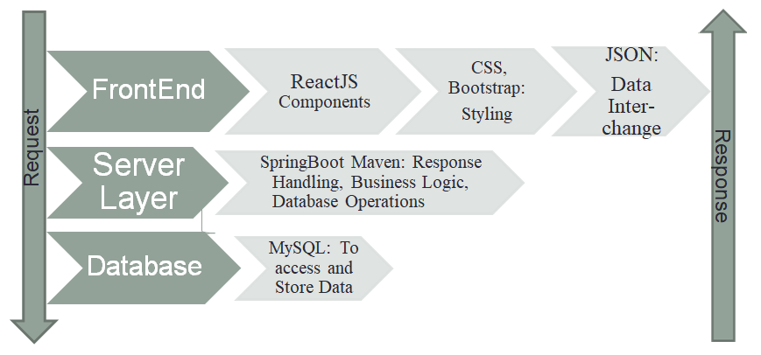

**Stage 1 - Front End Development:** In the first part, we're creating the part of the project that users interact with. We're using ReactJS, which helps us make the website responsive and dynamic. For making wep page presentable, we're using CSS and Bootstrap. When the website needs to get or show data, we're using JSON, a way for computers to share information.

**Stage 2 - Backend Development:** In the second part, we're building the behind-the-scenes work of the project. We're using Spring Boot with Java to manage how the website connects to the server. It handles requests from the front end and takes care of how data should be processed. Its like the manager between the front end and the database.

**Stage 3 - Database Management:** In the last part, we're setting up where all the important project data is stored. We've chosen MySQL for this. It's like a digital organized storage room. Spring Boot from the previous stage talks to MySQL to save new information, find existing data, and do other tasks to keep things running smoothly.

.

* **High Level Design:**
* **E-R Diagram:**

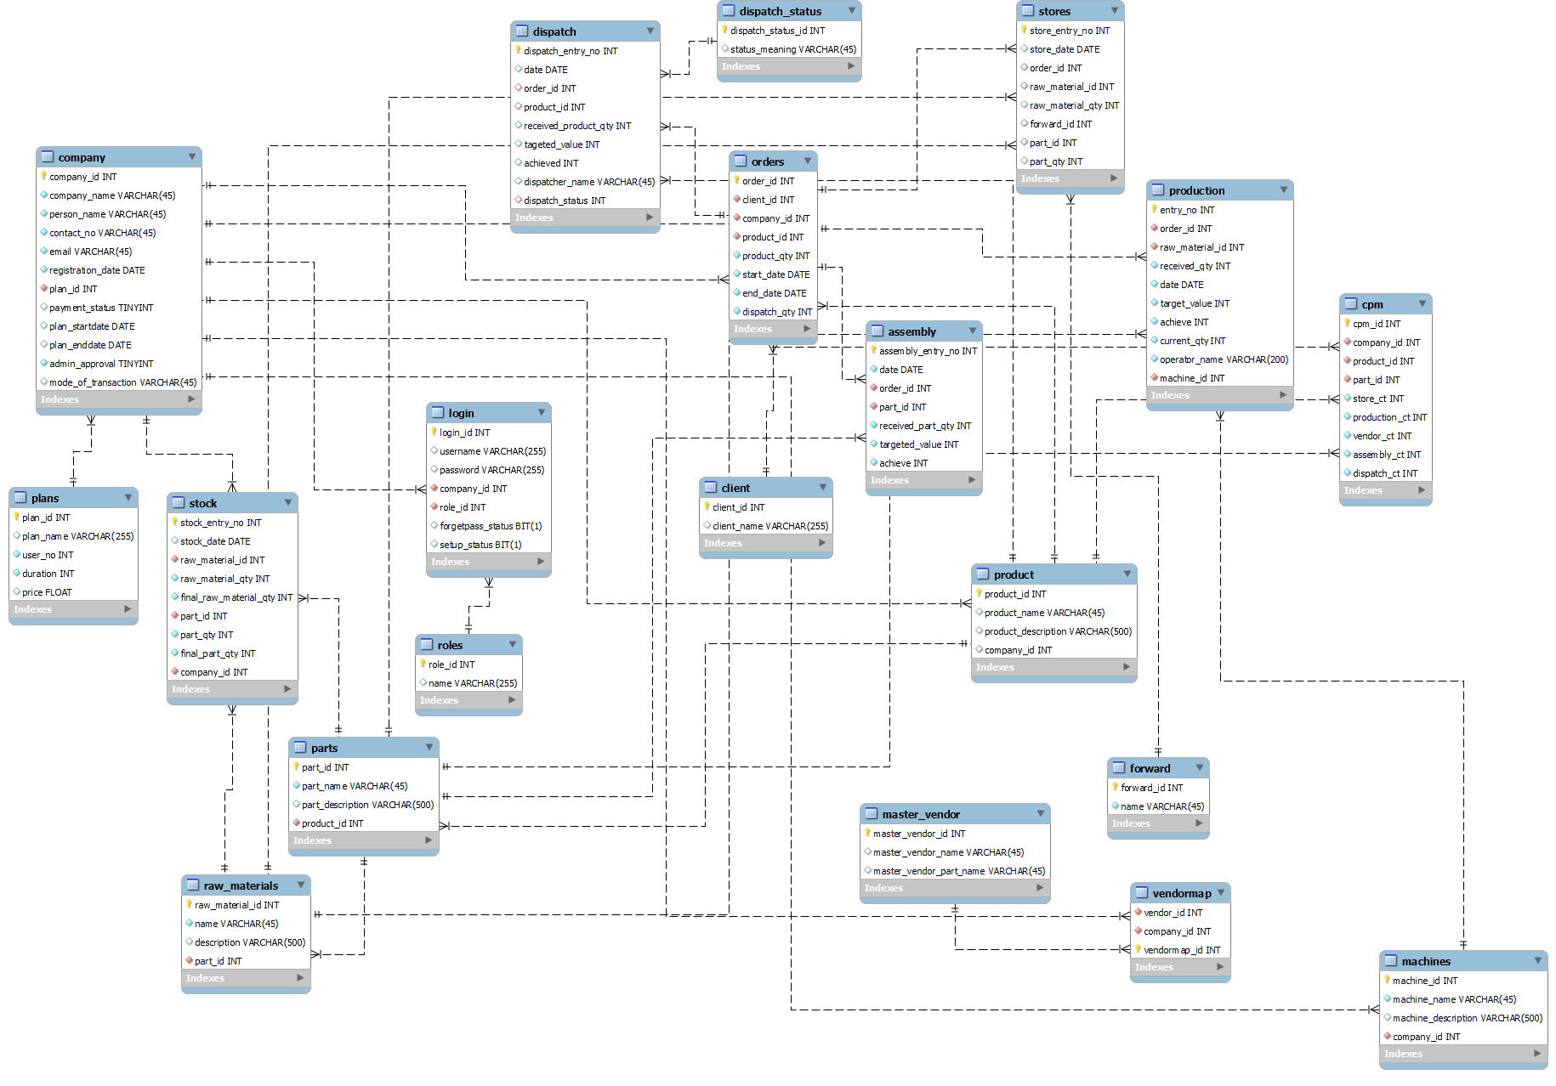

Above E-R Diagram shows that database of OptiSync system consist of following entities:

1. **Client Table:**
   * Fields: client_id (Primary Key), client_name
   * Description: Stores information about clients interacting with the system.
2. **Plans Table:**
   * Fields: plan_id (Primary Key), plan_name, user_no, duration, price
   * Description: Contains details about different plans offered to clients.
3. **Company Table:**
   * Fields: company_id (Primary Key), company_name, person_name, contact_no, email, registration_date, plan_id (Foreign Key), payment_status, plan_startdate, plan_enddate, admin_approval, mode_of_transaction
   * Description: Stores information about companies registered in the system, their plans, and related details.
4. **Product Table:**
   * Fields: product_id (Primary Key), product_name, product_description, company_id (Foreign Key)
   * Description: Holds data about products offered by companies.
5. **Orders Table:**
   * Fields: order_id (Primary Key), client_id (Foreign Key), company_id (Foreign Key), product_id (Foreign Key), product_qty, start_date, end_date, dispatch_qty
   * Description: Manages orders placed by clients, containing product and company references.
6. **Parts Table:**
   * Fields: part_id (Primary Key), part_name, part_description, product_id (Foreign Key)
   * Description: Stores parts used in the production of products.
7. **Assembly Table:**
   * Fields: assembly_entry_no (Primary Key), date, order_id (Foreign Key), part_id (Foreign Key), received_part_qty, targeted_value, achieve
   * Description: Records assembly details, including parts and quantities.
8. **CPM Table:**
   * Fields: cpm_id (Primary Key), company_id (Foreign Key), product_id (Foreign Key), part_id (Foreign Key), store_ct, production_ct, vendor_ct, assembly_ct, dispatch_ct
   * Description: Keeps track of various cycle times for company-product-part combinations.
9. **Dispatch Status Table:**
   * Fields: dispatch_status_id (Primary Key), status_meaning
   * Description: Stores different dispatch status meanings.
10. **Dispatch Table:**
    * **Fields: dispatch_entry_no (Primary Key), date, order_id (Foreign Key), product_id (Foreign Key), received_product_qty, tageted_value, achieved, dispatcher_name, dispatch_status (Foreign Key)**
    * **Description: Tracks dispatch information for orders, including product quantities and status.**
11. **Forward Table:**
    * Fields: forward_id (Primary Key), name
    * Description: Records names for forwarding purposes.
12. **Roles Table:**
    * Fields: role_id (Primary Key), name
    * Description: Stores different user roles.
13. **Login Table:**
    * Fields: login_id (Primary Key), username, password, company_id (Foreign Key), role_id (Foreign Key), forgetpass_status, setup_status
    * Description: Manages login credentials and user roles.
14. **Machines Table:**
    * Fields: machine_id (Primary Key), machine_name, machine_description, company_id (Foreign Key)
    * Description: Contains information about machines used by companies.
15. **Master Vendor Table:**
    * Fields: master_vendor_id (Primary Key), master_vendor_name, master_vendor_part_name
    * Description: Stores details about master vendors and their parts.
16. **Raw Materials Table:**
    * Fields: raw_material_id (Primary Key), name, description, part_id (Foreign Key)
    * Description: Keeps track of raw materials related to parts.
17. **Production Table:**
    * Fields: entry_no (Primary Key), order_id (Foreign Key), raw_material_id (Foreign Key), received_qty, date, target_value, achieve, current_qty, operator_name, machine_id (Foreign Key)
    * Description: Records production details, including targets and achievements.
18. **Stock Table:**
    * Fields: stock_entry_no (Primary Key), stock_date, raw_material_id (Foreign Key), raw_material_qty, final_raw_material_qty, part_id (Foreign Key), part_qty, final_part_qty, company_id (Foreign Key)
    * Description: Tracks stock levels of raw materials and parts.
19. **Stores Table:**
    * Fields: store_entry_no (Primary Key), store_date, order_id (Foreign Key), raw_material_id (Foreign Key), raw_material_qty, forward_id (Foreign Key), part_id (Foreign Key), part_qty
    * Description: Records movements of raw materials and parts in stores.
20. **Vendor Map Table:**
    * Fields: vendor_id (Primary Key), company_id (Primary Key), vendormap_id (Primary Key)
    * Description: Maps vendors to companies.

* **Data Base Details:**
* **Database Design:**

1. Client

|  |  |  |
| --- | --- | --- |
| **Field** | **Data Type** | **Constraints** |
| client_id | int | Primary Key |
| client_name | varchar(255) |  |

1. Plans

|  |  |  |
| --- | --- | --- |
| **Field** | **Data Type** | **Constraints** |
| plan_id | int | Primary Key |
| plan_name | varchar |  |
| user_no | int |  |
| duration | int |  |
| price | float |  |

1. Company

|  |  |  |
| --- | --- | --- |
| **Field** | **Data Type** | **Constraints** |
| company_id | int | Primary Key |
| company_name | varchar(45) | Not Null |
| person_name | varchar(45) | Not Null |
| contact_no | varchar(45) | Not Null |
| email | varchar(45) | Not Null |
| registration_date | date | Not Null |
| plan_id | int | Not Null, Foreign Key |
| payment_status | tinyint |  |
| plan_startdate | date | Default Null |
| plan_enddate | date | Default Null |
| admin_approval | tinyint | Default 0 |
| mode_of_transaction | varchar(45) | Default 'Online' |

1. Product Table

|  |  |  |
| --- | --- | --- |
| **Field** | **Data Type** | **Constraints** |
| product_id | int | Primary Key |
| product_name | varchar(45) |  |
| product_description | varchar(500) |  |
| company_id | int | Foreign Key |

1. Order Table

|  |  |  |
| --- | --- | --- |
| **Field** | **Data Type** | **Constraints** |
| order_id | int | Primary Key |
| client_id | int | Foreign Key |
| company_id | int | Foreign Key |
| product_id | int | Foreign Key |
| product_qty | int |  |
| start_date | date |  |
| end_date | date |  |
| dispatch_qty | int | Default 0 |

1. Parts Table

|  |  |  |
| --- | --- | --- |
| **Field** | **Data Type** | **Constraints** |
| part_id | int | Primary Key |
| part_name | varchar(45) | Not Null |
| part_description | varchar(500) | Default Null |
| product_id | int | Foreign Key |

1. Assembly Table

|  |  |  |
| --- | --- | --- |
| **Field** | **Data Type** | **Constraints** |
| assembly_entry_no | int | Primary Key |
| date | date |  |
| order_id | int | Foreign Key |
| part_id | int | Foreign Key |
| received_part_qty | int |  |
| targeted_value | int |  |
| achieve | int |  |

1. CPM

|  |  |  |
| --- | --- | --- |
| **Field** | **Data Type** | **Constraints** |
| cpm_id | int | Primary Key |
| company_id | int | Foreign Key |
| product_id | int | Foreign Key |
| part_id | int | Foreign Key |
| store_ct | int |  |
| production_ct | int |  |
| vendor_ct | int |  |
| assembly_ct | int |  |
| dispatch_ct | int |  |

1. Dispatch Status

|  |
| --- |
|  |
| **Field** | **Data Type** | **Constraints** |
| dispatch_status_id | int | Primary Key |
| status_meaning | varchar(45) |  |

1. Dispatch

|  |  |  |
| --- | --- | --- |
| **Field** | **Data Type** | **Constraints** |
| dispatch_entry_no | int | Primary Key |
| date | date | Default Null |
| order_id | int | Foreign Key |
| product_id | int | Foreign Key |
| received_product_qty | int | Default Null |
| tageted_value | int | Default Null |
| achieved | int | Default Null |
| dispatcher_name | varchar(45) | Default Null |
| dispatch_status | int | Foreign Key |

11 Forward

|  |  |  |
| --- | --- | --- |
| **Field** | **Data Type** | **Constraints** |
| forward_id | int | Primary Key |
| name | varchar(45) | Not Null |

12 Roles

|  |
| --- |
|  |
| **Field** | **Data Type** | **Constraints** |
| role_id | int | Primary Key |
| name | varchar(255) |  |

13 Login

|  |  |  |
| --- | --- | --- |
| **Field** | **Data Type** | **Constraints** |
| login_id | int | Primary Key |
| username | varchar(255) | Default Null |
| password | varchar(255) | Default Null |
| company_id | int | Foreign Key |
| role_id | int | Foreign Key |
| forgetpass_status | bit(1) | Default Null |
| setup_status | bit(1) | Default Null |

14 Machines Table

|  |  |  |
| --- | --- | --- |
| **Field** | **Data Type** | **Constraints** |
| machine_id | int | Primary Key |
| machine_name | varchar(45) | Not Null |
| machine_description | varchar(500) | Default Null |

15 Master Vendor

|  |  |  |
| --- | --- | --- |
| **Field** | **Data Type** | **Constraints** |
| machine_id | int | Primary Key |
| machine_name | varchar(45) | Not Null |
| machine_description | varchar(500) | Default Null |

16 Raw Material

|  |  |  |
| --- | --- | --- |
| **Field** | **Data Type** | **Constraints** |
| raw_material_id | int | Primary Key |
| name | varchar(45) | Not Null |
| description | varchar(500) | Default Null |
| part_id | int | Foreign Key |

17 Production

|  |  |  |
| --- | --- | --- |
| **Field** | **Data Type** | **Constraints** |
| entry_no | int | Primary Key |
| order_id | int | Foreign Key |
| raw_material_id | int | Foreign Key |
| received_qty | int |  |
| date | date |  |
| target_value | int |  |
| achieve | int |  |
| current_qty | int |  |
| operator_name | varchar(200) | Not Null |
| machine_id | int | Foreign Key |

18 Stock

|  |  |  |
| --- | --- | --- |
| stock_entry_no | int | Primary Key |
| stock_date | date | Default Null |
| raw_material_id | int | Foreign Key |
| raw_material_qty | int |  |
| final_raw_material_qty | int |  |
| part_id | int | Foreign Key |
| part_qty | int |  |
| final_part_qty | int |  |
| company_id | int | Foreign Key |

19 Stores

|  |  |  |
| --- | --- | --- |
| **Field** | **Data Type** | **Constraints** |
| store_entry_no | int | Primary Key |
| store_date | date | Default Null |
| order_id | int | Foreign Key |
| raw_material_id | int | Foreign Key |
| raw_material_qty | int | Default Null |
| forward_id | int | Foreign Key |
| part_id | int | Foreign Key |
| part_qty | int | Default Null |

20 Vendor Map

|  |  |  |
| --- | --- | --- |
| **Field** | **Data Type** | **Constraints** |
| vendor_id | int | Foreign Key |
| company_id | int | Foreign Key |
| vendormap_id | int | Primary Key |